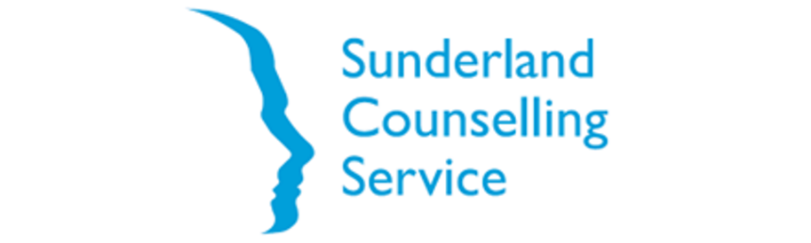
CONSULTANT BRIEF - July 2026
1. Background
Sunderland Counselling Service (SCS) is a well-established voluntary sector organisation delivering high-quality mental health, counselling and Talking Therapies services across the North East. Based in Sunderland and founded over 40 years ago, we were created by volunteers committed to ensuring that emotional and mental health support is accessible to all. That founding principle remains central to our work today.
Our mission is to improve mental health and wellbeing, alleviate emotional distress, and empower individuals to live independently as valued members of their communities. We provide specialist support to adults, children and young people, including survivors of sexual abuse and violence, individuals experiencing bereavement, carers, NHS patients and staff, and those living with long-term health conditions.
SCS delivers a broad and integrated range of services across community, primary care, and specialist settings, including:
- NHS Talking Therapies across multiple North East geographies
- Primary Care counselling in Sunderland
- Specialist counselling for survivors of sexual violence across Northumbria
- Bereavement and hospice-based support (St Benedict’s Hospice)
- Cancer support services in partnership with various NHS providers
- Children and Young People’s counselling in collaboration with CYPMHS
- Carers counselling and NHS staff wellbeing services
- School-based counselling across nine Sunderland settings

2. Purpose of the Commission
As a well-established charity and company limited by guarantee, we are not looking to review or change our overall governance or legal structure. Rather, SCS is undertaking this work proactively to test whether the organisation is set up appropriately for its current scale, complexity and future direction. Services, partnerships and supporting functions have developed over time, and SCS now wishes to assess whether its structure, governance and assurance arrangements remain fit for purpose and fit for the future.
The purpose of this commission is to support Sunderland Counselling Service to:
- ensure our ability to deliver our current services safely and effectively.
- ensure our ability to deliver on our contractual and grant obligations to our various commissioners, contractors and funders.
- improve our relationships, accountability to and influence with partners, commissioners and funders.
- ensure our ability to meet our obligations under HR and employment law to our staff teams.
- improve our organisational communication, culture and coherence.
- position us for future growth or development.
We have identified an initial set of questions we would like to consider, including:
- Is our organisational structure sensible and fit for purpose – specifically line management and operational reporting structures?
- For certain key functions e.g. finance, HR, marketing, business development – have we got the structure right, enough staff, the right skill mix?
- Do our arrangements for clinical and operational oversight and governance of our direct services work – for us, our staff, our funders and our clients?
- Do our arrangements for clinical and operational oversight and assurance of partner and subcontracted services provide sufficient visibility of quality, risk, performance and contractual delivery, and enable SCS to manage these arrangements proactively?
- From the varying arrangements we have in place in subcontracted services, can we identify an ideal or best practice model?
- Do our staff teams in subcontracted services feel these arrangements work for them?
- Do our arrangements for IG / DSP work – specifically the SIRO / Caldicott Guardian / DSP lead roles?
3. Role of the Consultant
The consultant will:
- Carry out a mixture of 1-1 and focus group interviews, with the exact number and format to be agreed.
- Consult with our board of trustees, CEO and senior management team to gather their views.
- Consult with representatives of management and staff teams across our various services and projects to gather their views.
- Consult with representatives from key external partners, commissioners and contractors to gather views – specifically NENC ICB, CNTW, STSFT, MHM and TEWV.
- Review our current organisational structures – clinical, operational and financial – to assess their effectiveness and suitability.
- Take account of the current policy and strategy landscape affecting mental health service delivery, including but not limited to the NHS 10 Year plan and the current neighbourhood health agenda.
- Attend our annual general meeting as part of the review process and to present interim findings.
4. Expected Outputs:
- A Board-level report setting out findings, risks and recommendations, including any proposed changes to organisational structure and interim or preferred future arrangements.
- A practical transition plan setting out how SCS could move from its current arrangements towards the preferred future position.
- A set of guiding principles for implementing any recommended changes.
- A communication approach for our staff teams, taking account of likely anxiety and uncertainty this sort of process may produce.
- Stress testing and contingency planning for key roles and areas of organisational dependency.
- A set of principles or scenarios for growth and future development or indeed any unexpected contraction.

5. Timescale
The commission is expected to operate within a 3 month period, with detailed milestones agreed with the selected consultant at inception.
SCS has made an initial assumption that the work may require around 20 to 30 hours of interviews and focus groups, alongside time for preparation, analysis, desktop review and production of the final report and recommendations. Consultants are invited to test these assumptions and propose a proportionate approach based on the scope and depth of review required.
The current indicative assumption is approximately one to one and a half days per week across the commission period. This is not fixed, and bidders should set out the resource they consider necessary, including any assumptions about the number of interviews, focus groups, review activity and reporting requirements.
We would hope to have initial or interim outputs to present at our 2026 AGM, which is likely to be held in November 2026, which will form part of the review and consultation process. We would expect to receive final outputs by January 2027.
6. Reporting and Governance
The consultant will report directly to our CEO, who will in turn report to our board of trustees.
7. Confidentiality
The consultant will be granted full access to internal and potentially business sensitive information, therefore they will be expected to sign a binding confidentiality agreement.
8. Proposal Submission Requirements
Please submit a written proposal, which should include:
- Understanding of the brief and context
- Proposed methodology and approach
- Relevant experience
- Proposed personnel
- Indicative timetable and milestones
- Budget and fee proposal, including day rates and assumptions
- Declaration of independence and conflicts of interest
- References (minimum two)
9. Evaluation Criteria
The commission will be considered successful if it:
- Produces actionable and prioritised recommendations
- Is grounded in stakeholder insight and evidence
- Is implementable within SCS’s resource constraints
- Strengthens clarity of organisational structure and governance
Proposals will be assessed against:
- Understanding of the organisation and our ambition
- Quality and credibility of approach
- Relevant experience and track record
- Ability to operate as an independent, trusted facilitator
- Value for money
- Capacity to deliver within required timescales
10. Submission Details
Submission deadline: 5:00 p.m. Friday 21st August 2026
Submission method: By email to toby@sunderlandcounselling.org.uk
Contact for clarification questions: Toby Sweet, CEO

